# Pinewood Derby Race Day Instructions

# To be completed:

* Kiosk Setup (With remote instructions)
* Test Timer
* Running Race

# Race Passwords:

Crew: murphy

Coordinator: doyourbest

Number of times each scout should run each lane: 2

# Import Roster

1. Navigate to [Login | Scoutbook Plus (scouting.org)](https://advancements.scouting.org/login) and login
2. Click on **Roster**.

1. In the bottom right hand corner, change the setting to **75 / page**.

1. Highlight everyone in the roster.

1. Right click **Copy**.
2. Open Excel / Sheet Software.
3. Press **Control + V**.

1. Highlight **Columns C** through **I**. Ensure all rows are selected.
2. Right click **> Copy**.
3. Create a new sheet.
4. Right **Click > Paste Special**.
5. Select **Values >** Click **OK**.

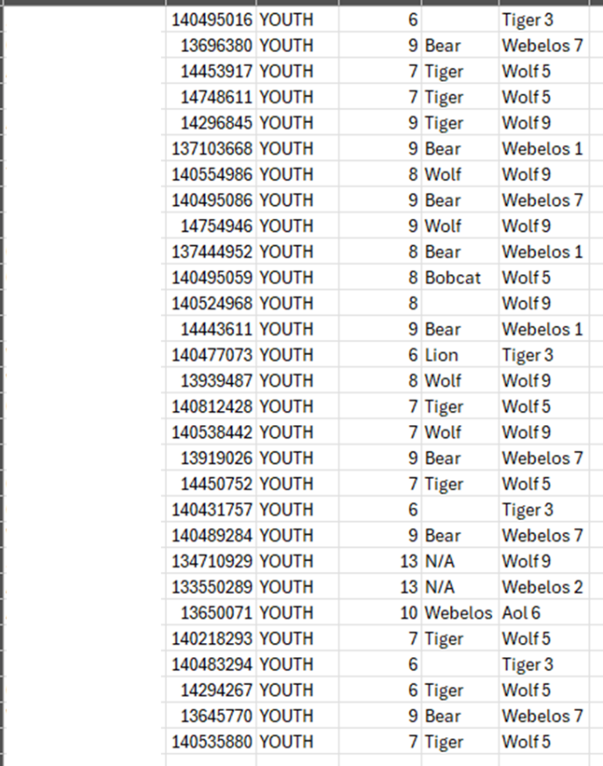

1. Delete the following columns:
   * Member ID, Type, Age, Last Rank, Position.

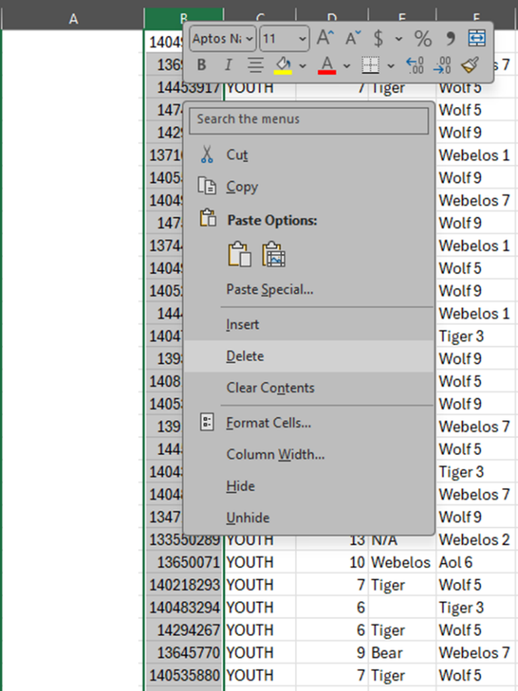

1. See Splitting Cell Information for Roster, and return to this step when finished.
2. When completed you should have a list that looks like this.

1. Assign each cub scout a number, use the table below to start with each number for each rank. Example, Lions always start with 1, Tigers always start with 101, etc..

|  |  |  |
| --- | --- | --- |
| **Rank** | **Starting Number** | **Ending Number** |
| Lion | 1 | 100 |
| Tiger | 101 | 200 |
| Wolf | 201 | 300 |
| Bears | 301 | 400 |
| Webelos | 401 | 500 |
| Aol | 501 | 600 |

1. Make sure each Den is labeled as the “Rank” in the table.

1. Click **File >** **Save As**.
2. Select **CSV (Comma delimited) (*.csv).**

1. Click **Save**.
2. Navigate to the page for the race.
3. Click **Log In**.

1. Select RaceCoordinator.

1. Type the password and press **Submit**.

1. Click **Setup**.

1. Click Import **Roster**.

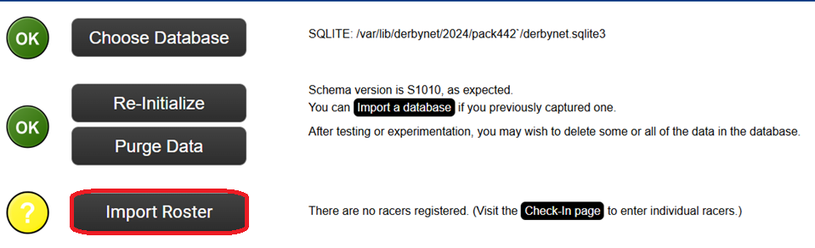

1. Select the race file we created in the earlier steps.
2. Click **Open**.

1. Drag **First Name**, **Last Name**, **Den** and **Car Number** to the headers that line up from the imported list.

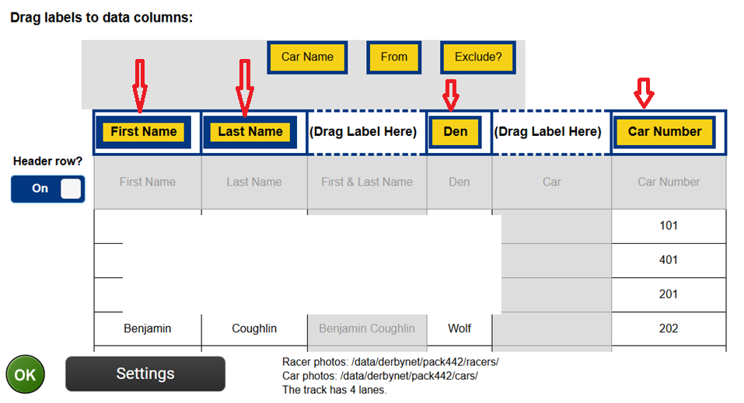

1. Click **Import Roster**.

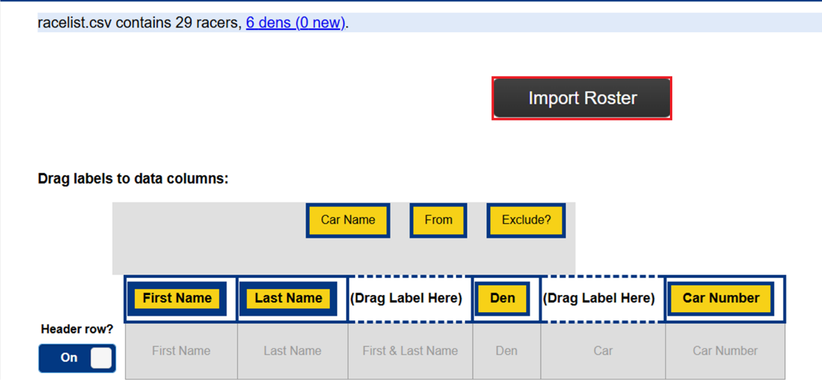

1. When completed, you will get a “Import complete!” and a green OK, down the left side.

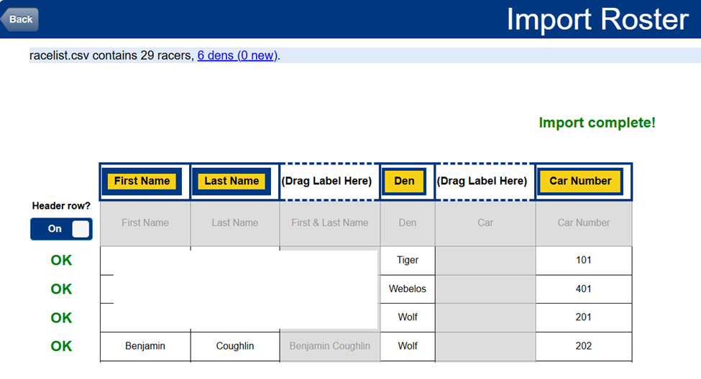

1. Click **Back** to bring you to the main set-up screen.

1. Click Back to bring you back to the main page.

# Setup Timer

At the current setup, the pack uses a NewBold Turbo timer. It is not detectable via the software, however there is a batch file that will start the timer with the required parameters. It is highly recommended to use the java based timer.

1. Navigate to [Pack442PineWoodDerby-main-main/Timer at main · majora15/Pack442PineWoodDerby-main-main (github.com)](https://github.com/majora15/Pack442PineWoodDerby-main-main/tree/main/Timer). Download the following two files:



* + Derby-timer.jar
  + Timer-start.bat

1. Place these files on the machine that will have the timer connected.
2. Make sure they are in the same location as each other.
3. Navigate to [Pack442PineWoodDerby-main-main/Drivers and Software/NewBoldProduct CD.zip at main · majora15/Pack442PineWoodDerby-main-main (github.com)](https://github.com/majora15/Pack442PineWoodDerby-main-main/blob/main/Drivers%20and%20Software/NewBoldProduct%20CD.zip).
4. Download the file.



1. Exact the contents of the zip file.
2. On the computer that will have the timer connected. Navigate to USB Driver\x64.
3. Copy the files to a temporary location c:\temp\USB Driver.

NOTE: Alternatively, you can Navigate to USB Drivers and click on CP210xVCPInstaller_xBB. BB being either 64 or 86. Most modern systems you will use x64.

1. When you connect the Timer to the PC, it will prompt for installation. If files are required navigate to the place you copied the files to in step 8.

# Testing Timer

Warning: This can only be done when you have the PC hooked up to the Timer.

# Checking Racers In

1. Navigate to the page for the race.
2. Click **Log In**.

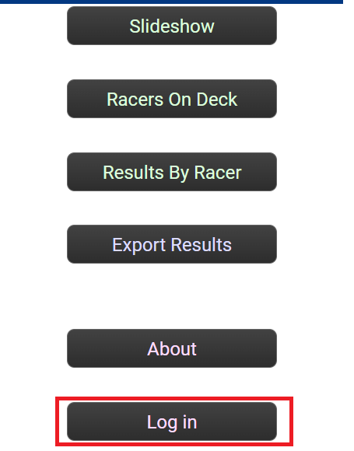

1. Select RaceCrew.

1. Type the password and press **Submit**.

1. Click on Race Check-In.

1. Locate the cub scout in the check in list.

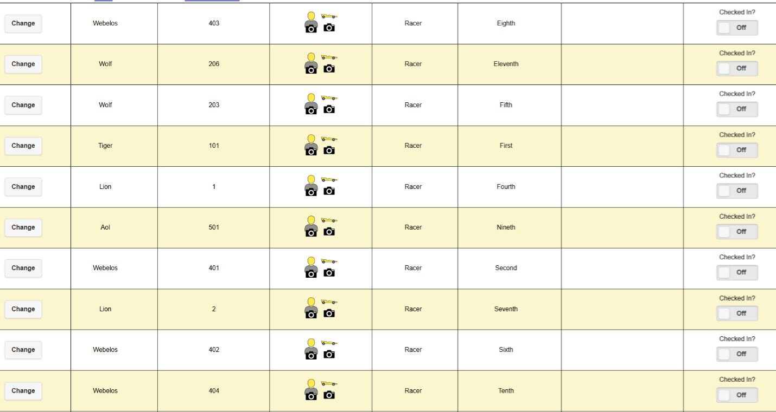

1. Make sure to weight and check the size of the car.
2. Take a picture of the car, using the camera icon for the car:



1. The Capture Car page will come up. Click **Capture & Check in**.

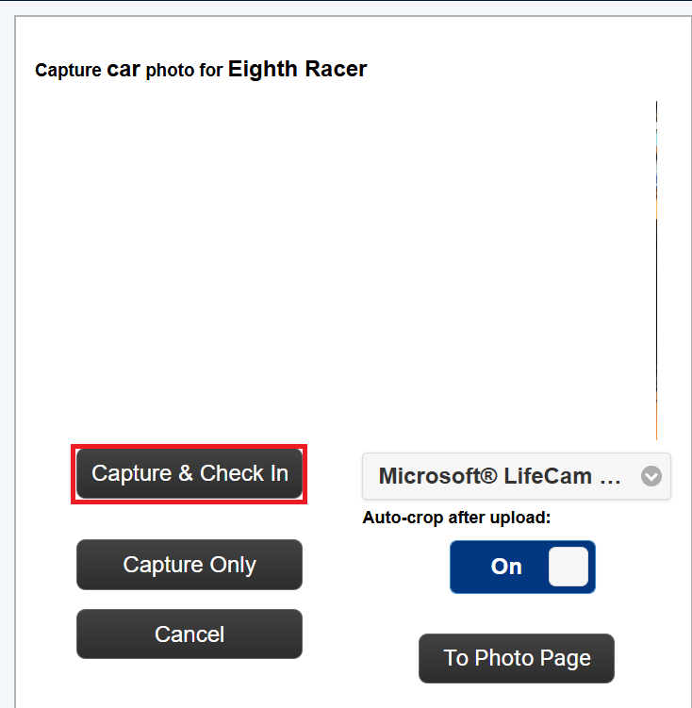

1. If you get the following notification, click **Allow**.

1. If names or something needs to be modified, you can click on **change**.(Optional)

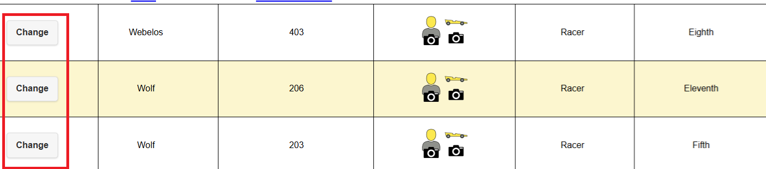

1. Modify any required information if needed and click **Submit**.

**NOTE:** Any racers not checked in can stay in the system as not checked in. This will not impact the race.

# Setting up Sibling / Outlaw Race (Optional)

1. Navigate to the page for the race.
2. Click **Log In**.

1. Select RaceCoordinator.

1. Type the password and press **Submit**.

1. Click Set-up

1. Click Racing Groups

1. Click **New Group**.

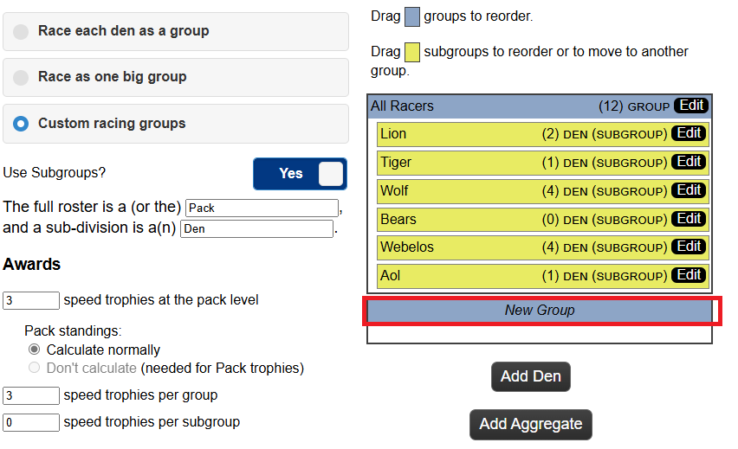

1. Provide the following:
   1. The new group name, either Siblings or Outlaw Racers.
   2. Number of speed trophies: 0.
   3. Click Submit.

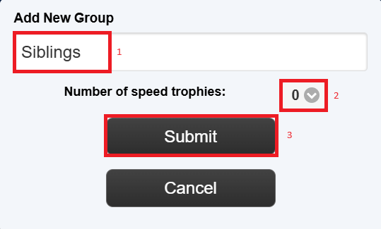

1. Click **Back**.

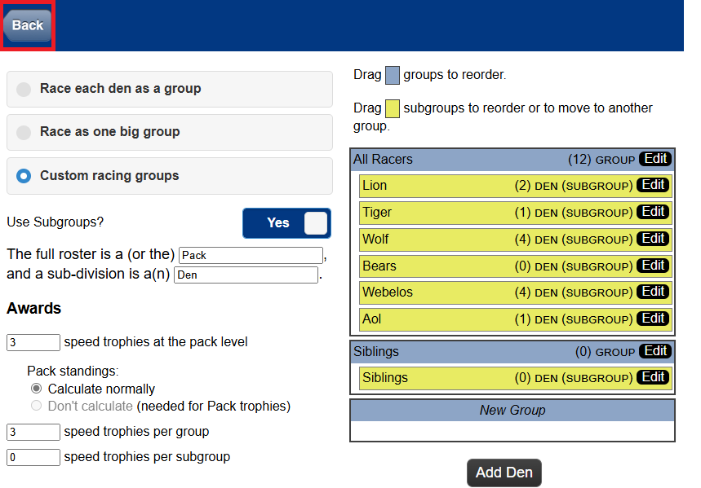

1. Click **Back**.

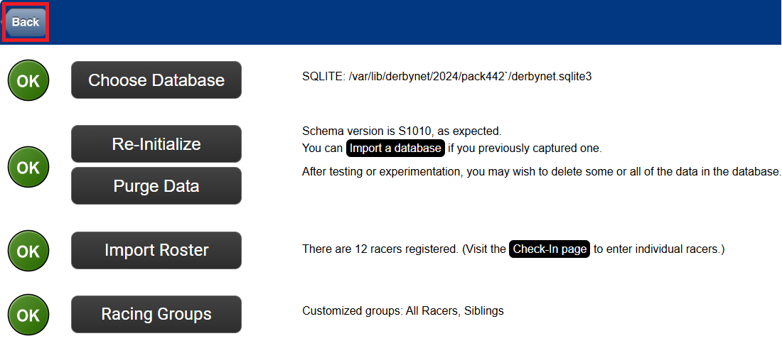

1. Click **Race Check-In**.

1. Click **New Racer**.

1. Provide the following:
   1. First Name
   2. Last Name
   3. Car Number (Number should start at 701 or higher).
   4. Den: Siblings (or Outlaw Racers)
   5. Trophy eligibility: Excluded.
2. Click **Submit**.

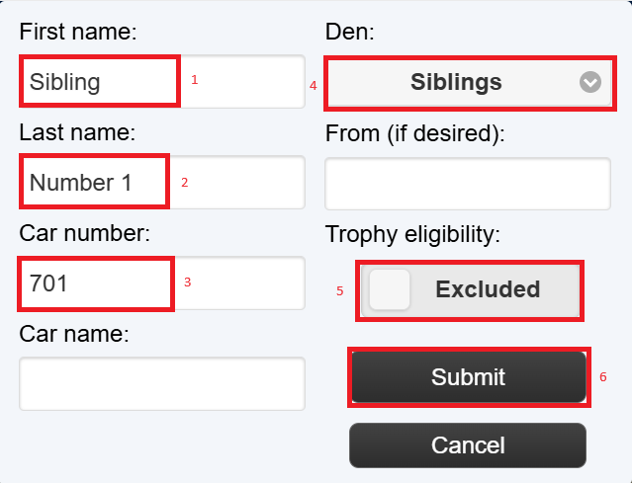

# Setting up races

1. Navigate to the page for the race.
2. Click **Log In**.

1. Select RaceCoordinator.

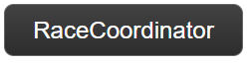

1. Type the password and press **Submit**.

1. Click on **Race Dashboard**

1. Expand **Round 1** and click **Schedule**.

1. Select the number of times each scout should appear on each lane. Click **Scheduled Only**.

1. Repeat **Steps 6** and **7** for the Sibling / Outlaw Race if required.

# Setting Up Kiosks

1. Navigate to the page for the race.
2. Click **Log In**.

1. Select RaceCoordinator.

1. Type the password and press **Submit**.

1. Click **Kiosk Dashboard**.

# Switching Scenes

1. Navigate to the page for the race.
2. Click **Log In**.

1. Select RaceCoordinator.

1. Type the password and press **Submit**.

1. Click **Kiosk Dashboard**.

1. Click **Current Scene**.

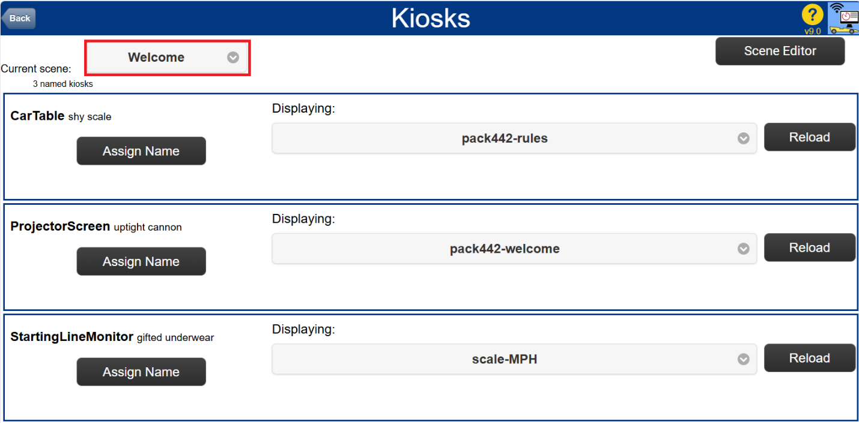

1. Select the Scene to set the Kiosks to at that time. You will do this several times through the event. Make sure to change this during Opening (Flags), After Flags (Check-In), Racing, Awards, and Wrap-Up.

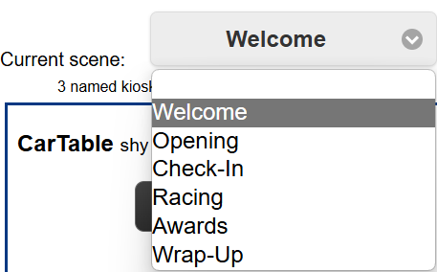

1. Click **Back**.

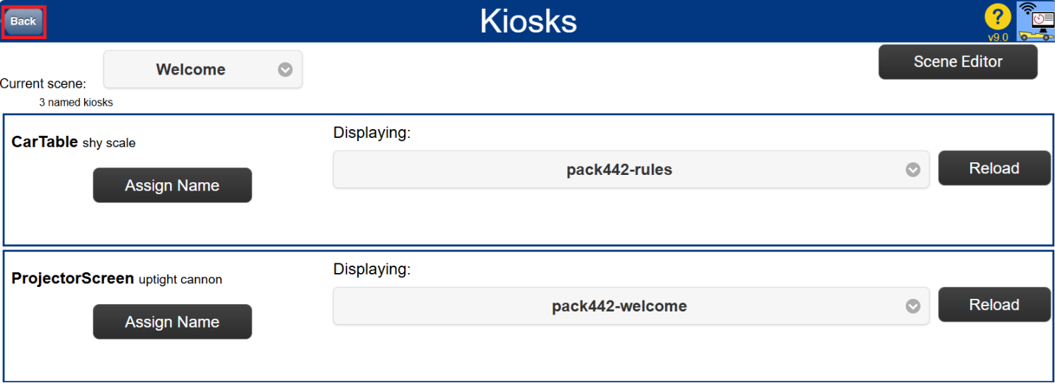

# Appendix

## Splitting Cell Information for Roster

1. Right click Column B “Den”.
2. Select Insert. Repeat this step 1 more time.

1. Select All scout names.
2. Click Text to Columns.

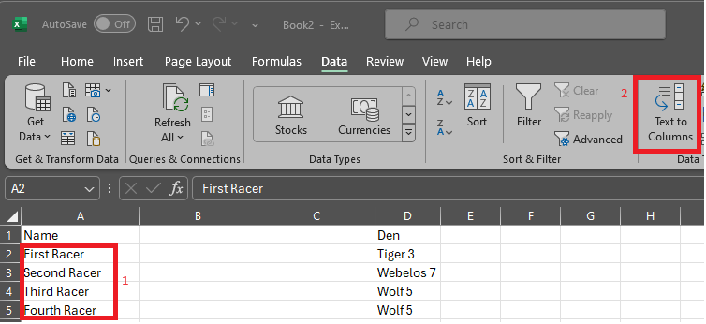

1. Click Next.

1. Make sure just Space is checked, click Next.

1. Click Finish.

1. When finished you should have two columns, one for first name and last name.

1. Repeat these steps for Den Column. At the end you will remove the column that has the number, and your spreadsheet should look like this:

1. Continue to the next step.